Alex Shah
Project 5 - ESP8266 Weather Station
2024-03-17
EN.605.715.81.SP24
Table of Contents
Requirements 1
Design 1
Implementation 2
Demo 2
References 2
Appendix 2

Requirements
The requirements for the weather station are to assemble the weather station kit, with a temperature and humidity sensor dht11, an arduino with esp8266 wifi, and oled screen. The wifi should connect to a network in order to receive openweathermap data to display from the api, and send thingspeak data to the thingspeak api. The oled screen should display weather data.

Design
I implemented the weather station kit with the dht11 sensor and arduino with esp8266 on a breadboard with wires connecting the screen to sda, scl, vcc, and ground to arduino pins d3, d4. The dht11 is connected with signal wire in the middle to d5 pin, and power and ground on the external pins. The other sensors were connected as described in the figure included in the weather station documentation, but not utilized.
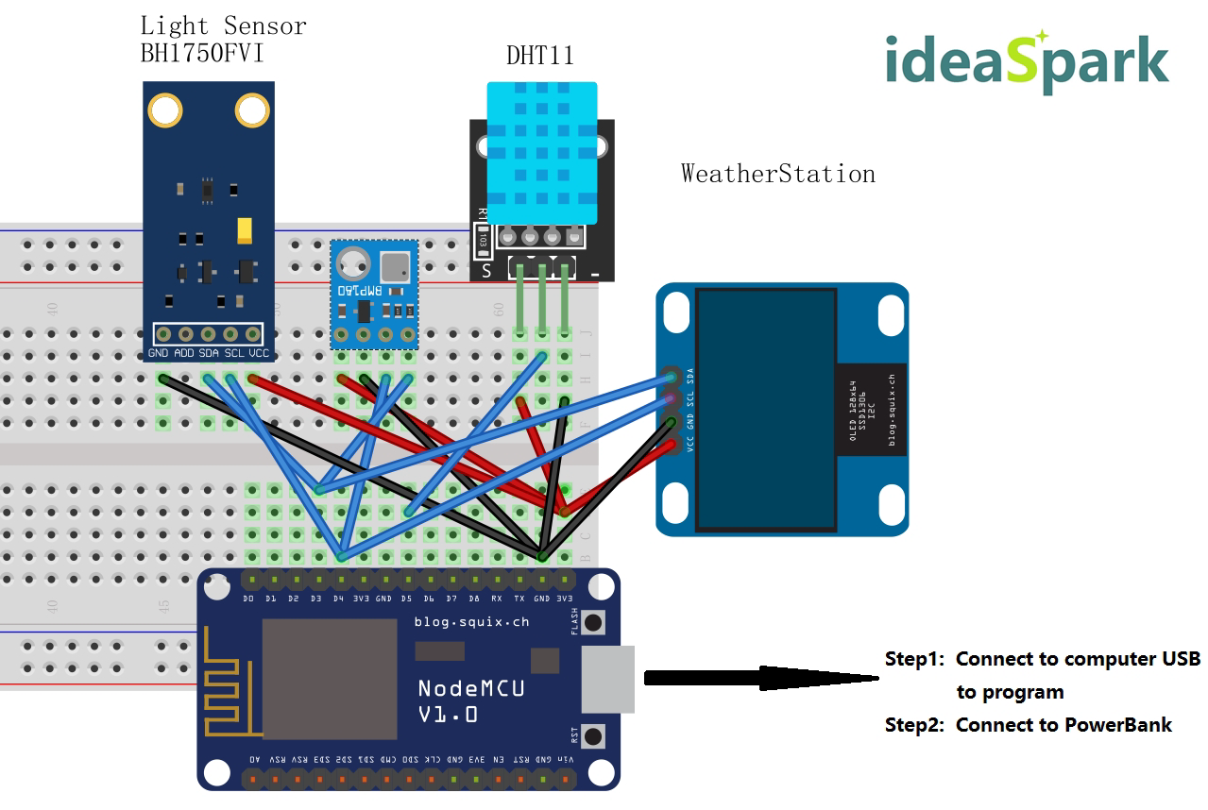
Figure 1. Board Design

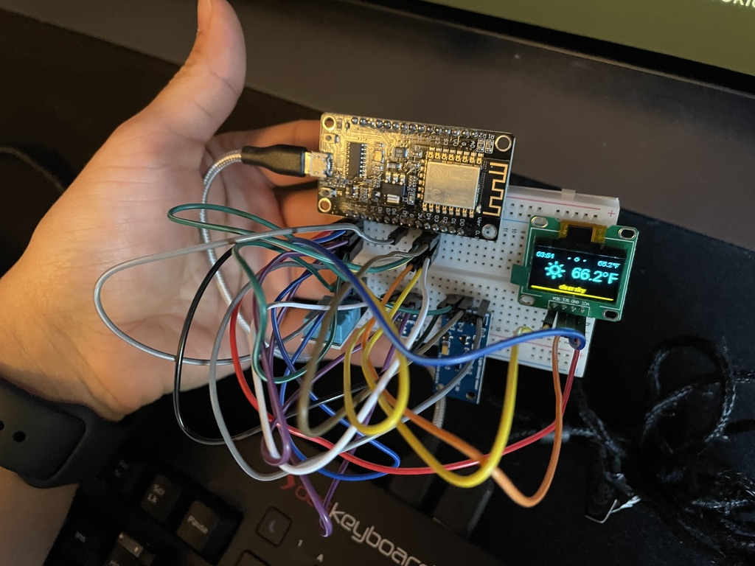

Figure 2. Board Implementation

Implementation
The project was breadboarded and assembled, then the code was abstracted from the weather station example WeatherStationDemo.ino in order to display weather data from openweathermap, as well as send back temperature and humidity data to thingspeak.
Please see WeatherStation.ino in the appendix.

Demo
Please see an example video showing the project running, and data sent back to thingspeak api appearing on screen.
https://drive.google.com/file/d/1L-ZHL_B-4WEMn7UQs-o77NeVDBxbv2BV/view?usp=sharing

References
https://github.com/GJKJ/WSKS/blob/master/Guide%20Manual(Read%20Me%20First).doc

Appendix

```WeatherStation.ino

1 #include <Arduino.h>
2 #if defined(ESP8266)
3 #include <ESP8266WiFi.h>
4 #include <coredecls.h> // settimeofday_cb()
5 #else
6 #include <WiFi.h>
7 #endif
8 #include <ESPHTTPClient.h>
9 #include <JsonListener.h>
10 // time
11 #include <time.h> // time() ctime()
12 #include <sys/time.h> // struct timeval
13 #include "SSD1306Wire.h"
14 #include "OLEDDisplayUi.h"
15 #include "Wire.h"
16 #include "OpenWeatherMapCurrent.h"
17 #include "OpenWeatherMapForecast.h"
18 #include "WeatherStationFonts.h"
19 #include "WeatherStationImages.h"
20 #include <Adafruit_BMP085.h>
21
22 /***************************
23 * WIFI Settings
24 **************************/
25 const char *WIFI_SSID = "####";
26 const char *WIFI_PWD = "####";
27
28 /***************************
29 * Begin DHT11 Settings
30 **************************/
31 WiFiClient client;
32 const char *host = "api.thingspeak.com"; // IP address of the thingspeak server
33 const char *api_key = "####"; // Your own thingspeak api_key
34 const int httpPort = 80;
35 #define pin 14 // ESP8266-12E D5 read emperature and Humidity data
36 int temp = 0; // temperature
37 int humi = 0; // humidity
38 void readTemperatureHumidity();
39 void uploadTemperatureHumidity();
40 long readTime = 0;
41 long uploadTime = 0;
42
43 /***************************
44 * Begin Atmosphere and Light Sensor Settings
45 **************************/
46 // void readLight();
47 // void readAtmosphere();
48 // Adafruit_BMP085 bmp;
49 // const int Light_ADDR = 0b0100011; // address:0x23
50 // const int Atom_ADDR = 0b1110111; // address:0x77
51 // int tempLight = 0;
52 // int tempAtom = 0;
53
54 /***************************
55 * Begin Settings
56 **************************/
57 #define TZ 5 // (utc+) TZ in hours
58 #define DST_MN 60 // use 60mn for summer time in some countries
59
60 // Setup
61 const int UPDATE_INTERVAL_SECS = 20 * 60; // Update every 20 minutes
62 // Display Settings
63 const int I2C_DISPLAY_ADDRESS = 0x3c;
64 #if defined(ESP8266)
65 // const int SDA_PIN = D1;
66 // const int SDC_PIN = D2;
67
68 const int SDA_PIN = D3;
69 const int SDC_PIN = D4;
70 #else
71 // const int SDA_PIN = GPIO5;
72 // const int SDC_PIN = GPIO4
73
74 const int SDA_PIN = GPIO0;
75 const int SDC_PIN = GPIO2
76 #endif
77
78 // OpenWeatherMap Settings
79 // Sign up here to get an API key:
80 // https://docs.thingpulse.com/how-tos/openweathermap-key/
81 const boolean IS_METRIC = false;
82 // Add your own thingpulse ID
83 String OPEN_WEATHER_MAP_APP_ID = "####";
84 String OPEN_WEATHER_MAP_LOCATION = "New York,NY,US";
85
86 // Pick a language code from this list:
87 // Arabic - ar, Bulgarian - bg, Catalan - ca, Czech - cz, German - de, Greek - el,
88 // English - en, Persian (Farsi) - fa, Finnish - fi, French - fr, Galician - gl,
89 // Croatian - hr, Hungarian - hu, Italian - it, Japanese - ja, Korean - kr,
90 // Latvian - la, Lithuanian - lt, Macedonian - mk, Dutch - nl, Polish - pl,
91 // Portuguese - pt, Romanian - ro, Russian - ru, Swedish - se, Slovak - sk,
92 // Slovenian - sl, Spanish - es, Turkish - tr, Ukrainian - ua, Vietnamese - vi,
93 // Chinese Simplified - zh_cn, Chinese Traditional - zh_tw.
94
95 String OPEN_WEATHER_MAP_LANGUAGE = "en";
96 const uint8_t MAX_FORECASTS = 4;
97
98 // Adjust according to your language
99 const String WDAY_NAMES[] = {"SUN", "MON", "TUE", "WED", "THU", "FRI", "SAT"};
100 const String MONTH_NAMES[] = {"JAN", "FEB", "MAR", "APR", "MAY", "JUN", "JUL", "AUG", "SEP", "OCT", "NOV", "DEC"};
101
102 /***************************
103 * End Settings
104 **************************/
105 // Initialize the oled display for address 0x3c
106 SSD1306Wire display(I2C_DISPLAY_ADDRESS, SDA_PIN, SDC_PIN);
107 OLEDDisplayUi ui(&display);
108
109 OpenWeatherMapCurrentData currentWeather;
110 OpenWeatherMapCurrent currentWeatherClient;
111
112 OpenWeatherMapForecastData forecasts[MAX_FORECASTS];
113 OpenWeatherMapForecast forecastClient;
114
115 #define TZ_MN ((TZ) * 60)
116 #define TZ_SEC ((TZ) * 3600)
117 #define DST_SEC ((DST_MN) * 60)
118 time_t now;
119
120 // flag changed in the ticker function every 10 minutes
121 bool readyForWeatherUpdate = false;
122 String lastUpdate = "--";
123 long timeSinceLastWUpdate = 0;
124 // declaring prototypes
125 void drawProgress(OLEDDisplay *display, int percentage, String label);
126 void updateData(OLEDDisplay *display);
127 void drawDateTime(OLEDDisplay *display, OLEDDisplayUiState *state, int16_t x, int16_t y);
128 void drawCurrentWeather(OLEDDisplay *display, OLEDDisplayUiState *state, int16_t x, int16_t y);
129 void drawForecast(OLEDDisplay *display, OLEDDisplayUiState *state, int16_t x, int16_t y);
130 void drawForecastDetails(OLEDDisplay *display, int x, int y, int dayIndex);
131 void drawHeaderOverlay(OLEDDisplay *display, OLEDDisplayUiState *state);
132 void setReadyForWeatherUpdate();
133
134 // Add frames
135 // this array keeps function pointers to all frames
136 // frames are the single views that slide from right to left
137 FrameCallback frames[] = {drawDateTime, drawCurrentWeather, drawForecast};
138 int numberOfFrames = 3;
139
140 OverlayCallback overlays[] = {drawHeaderOverlay};
141 int numberOfOverlays = 1;
142
143 void setup()
144 {
145 Serial.begin(115200);
146
147 Wire.begin(0, 2);
148
149 // Wire.beginTransmission(Atom_ADDR);
150 // //initialize Atmosphere sensor
151 // if (!bmp.begin()) {
152 // Serial.println("Could not find BMP180 or BMP085 sensor at 0x77");
153 // }else{
154 // Serial.println("Find BMP180 or BMP085 sensor at 0x77");
155 // }
156 // Wire.endTransmission();
157 //
158 // //initialize light sensor
159 // Wire.beginTransmission(Light_ADDR);
160 // Wire.write(0b00000001);
161 // Wire.endTransmission();
162
163 // initialize dispaly
164 display.init();
165 display.clear();
166 display.display();
167
168 // display.flipScreenVertically();
169 display.setFont(ArialMT_Plain_10);
170 display.setTextAlignment(TEXT_ALIGN_CENTER);
171 display.setContrast(255);
172
173 WiFi.begin(WIFI_SSID, WIFI_PWD);
174
175 int counter = 0;
176 while (WiFi.status() != WL_CONNECTED)
177 {
178 delay(500);
179 Serial.print(".");
180 display.clear();
181 display.drawString(64, 10, "Connecting to WiFi");
182 display.drawXbm(46, 30, 8, 8, counter % 3 == 0 ? activeSymbole : inactiveSymbole);
183 display.drawXbm(60, 30, 8, 8, counter % 3 == 1 ? activeSymbole : inactiveSymbole);
184 display.drawXbm(74, 30, 8, 8, counter % 3 == 2 ? activeSymbole : inactiveSymbole);
185 display.display();
186
187 counter++;
188 }
189 // Get time from network time service
190 configTime(TZ_SEC, DST_SEC, "pool.ntp.org");
191 ui.setTargetFPS(30);
192 ui.setActiveSymbol(activeSymbole);
193 ui.setInactiveSymbol(inactiveSymbole);
194 // You can change this to
195 // TOP, LEFT, BOTTOM, RIGHT
196 ui.setIndicatorPosition(BOTTOM);
197 // Defines where the first frame is located in the bar.
198 ui.setIndicatorDirection(LEFT_RIGHT);
199 // You can change the transition that is used
200 // SLIDE_LEFT, SLIDE_RIGHT, SLIDE_TOP, SLIDE_DOWN
201 ui.setFrameAnimation(SLIDE_LEFT);
202 ui.setFrames(frames, numberOfFrames);
203 ui.setOverlays(overlays, numberOfOverlays);
204 // Inital UI takes care of initalising the display too.
205 ui.init();
206 Serial.println("");
207 updateData(&display);
208 while (!client.connect(host, httpPort))
209 {
210 Serial.println("Connection Failed");
211 }
212 }
213
214 void loop()
215 {
216 // Read Temperature Humidity every 5 seconds
217 if (millis() - readTime > 5000)
218 {
219 readTemperatureHumidity();
220 // readLight();
221 // readAtmosphere();
222 readTime = millis();
223 }
224 // Upload Temperature Humidity every 60 seconds
225 if (millis() - uploadTime > 60000)
226 {
227 uploadTemperatureHumidity();
228 uploadTime = millis();
229 }
230
231 if (millis() - timeSinceLastWUpdate > (1000L * UPDATE_INTERVAL_SECS))
232 {
233 setReadyForWeatherUpdate();
234 timeSinceLastWUpdate = millis();
235 }
236
237 if (readyForWeatherUpdate && ui.getUiState()->frameState == FIXED)
238 {
239 updateData(&display);
240 }
241
242 int remainingTimeBudget = ui.update();
243
244 if (remainingTimeBudget > 0)
245 {
246 // You can do some work here
247 // Don't do stuff if you are below your
248 // time budget.
249 delay(remainingTimeBudget);
250 }
251 }
252
253 void drawProgress(OLEDDisplay *display, int percentage, String label)
254 {
255 display->clear();
256 display->setTextAlignment(TEXT_ALIGN_CENTER);
257 display->setFont(ArialMT_Plain_10);
258 display->drawString(64, 10, label);
259 display->drawProgressBar(2, 28, 124, 10, percentage);
260 display->display();
261 }
262
263 void updateData(OLEDDisplay *display)
264 {
265 drawProgress(display, 10, "Updating time...");
266 drawProgress(display, 30, "Updating weather...");
267 currentWeatherClient.setMetric(IS_METRIC);
268 currentWeatherClient.setLanguage(OPEN_WEATHER_MAP_LANGUAGE);
269 currentWeatherClient.updateCurrent(&currentWeather, OPEN_WEATHER_MAP_APP_ID, OPEN_WEATHER_MAP_LOCATION);
270 drawProgress(display, 50, "Updating forecasts...");
271 forecastClient.setMetric(IS_METRIC);
272 forecastClient.setLanguage(OPEN_WEATHER_MAP_LANGUAGE);
273 uint8_t allowedHours[] = {12};
274 forecastClient.setAllowedHours(allowedHours, sizeof(allowedHours));
275 forecastClient.updateForecasts(forecasts, OPEN_WEATHER_MAP_APP_ID, OPEN_WEATHER_MAP_LOCATION, MAX_FORECASTS);
276 readyForWeatherUpdate = false;
277 drawProgress(display, 100, "Done...");
278 delay(1000);
279 }
280
281 void drawDateTime(OLEDDisplay *display, OLEDDisplayUiState *state, int16_t x, int16_t y)
282 {
283 now = time(nullptr);
284 struct tm *timeInfo;
285 timeInfo = localtime(&now);
286 char buff[16];
287
288 display->setTextAlignment(TEXT_ALIGN_CENTER);
289 display->setFont(ArialMT_Plain_10);
290 String date = WDAY_NAMES[timeInfo->tm_wday];
291
292 sprintf_P(buff, PSTR("%s, %02d/%02d/%04d"), WDAY_NAMES[timeInfo->tm_wday].c_str(), timeInfo->tm_mday, timeInfo->tm_mon + 1, timeInfo->tm_year + 1900);
293 display->drawString(64 + x, 5 + y, String(buff));
294 display->setFont(ArialMT_Plain_24);
295
296 sprintf_P(buff, PSTR("%02d:%02d:%02d"), timeInfo->tm_hour, timeInfo->tm_min, timeInfo->tm_sec);
297 display->drawString(64 + x, 15 + y, String(buff));
298 display->setTextAlignment(TEXT_ALIGN_LEFT);
299 }
300
301 void drawCurrentWeather(OLEDDisplay *display, OLEDDisplayUiState *state, int16_t x, int16_t y)
302 {
303 display->setFont(ArialMT_Plain_10);
304 display->setTextAlignment(TEXT_ALIGN_CENTER);
305 display->drawString(64 + x, 38 + y, currentWeather.description);
306
307 display->setFont(ArialMT_Plain_24);
308 display->setTextAlignment(TEXT_ALIGN_LEFT);
309 String temp = String(currentWeather.temp, 1) + (IS_METRIC ? "°C" : "°F");
310 display->drawString(60 + x, 5 + y, temp);
311
312 display->setFont(Meteocons_Plain_36);
313 display->setTextAlignment(TEXT_ALIGN_CENTER);
314 display->drawString(32 + x, 0 + y, currentWeather.iconMeteoCon);
315 }
316
317 void drawForecast(OLEDDisplay *display, OLEDDisplayUiState *state, int16_t x, int16_t y)
318 {
319 drawForecastDetails(display, x, y, 0);
320 drawForecastDetails(display, x + 44, y, 1);
321 drawForecastDetails(display, x + 88, y, 2);
322 }
323
324 void drawForecastDetails(OLEDDisplay *display, int x, int y, int dayIndex)
325 {
326 time_t observationTimestamp = forecasts[dayIndex].observationTime;
327 struct tm *timeInfo;
328 timeInfo = localtime(&observationTimestamp);
329 display->setTextAlignment(TEXT_ALIGN_CENTER);
330 display->setFont(ArialMT_Plain_10);
331 display->drawString(x + 20, y, WDAY_NAMES[timeInfo->tm_wday]);
332
333 display->setFont(Meteocons_Plain_21);
334 display->drawString(x + 20, y + 12, forecasts[dayIndex].iconMeteoCon);
335 String temp = String(forecasts[dayIndex].temp, 0) + (IS_METRIC ? "°C" : "°F");
336 display->setFont(ArialMT_Plain_10);
337 display->drawString(x + 20, y + 34, temp);
338 display->setTextAlignment(TEXT_ALIGN_LEFT);
339 }
340
341 void drawHeaderOverlay(OLEDDisplay *display, OLEDDisplayUiState *state)
342 {
343 now = time(nullptr);
344 struct tm *timeInfo;
345 timeInfo = localtime(&now);
346 char buff[14];
347 sprintf_P(buff, PSTR("%02d:%02d"), timeInfo->tm_hour, timeInfo->tm_min);
348
349 display->setColor(WHITE);
350 display->setFont(ArialMT_Plain_10);
351 display->setTextAlignment(TEXT_ALIGN_LEFT);
352 display->drawString(0, 54, String(buff));
353 display->setTextAlignment(TEXT_ALIGN_RIGHT);
354 String temp = String(currentWeather.temp, 1) + (IS_METRIC ? "°C" : "°F");
355 display->drawString(128, 54, temp);
356 display->drawHorizontalLine(0, 52, 128);
357 }
358
359 void setReadyForWeatherUpdate()
360 {
361 Serial.println("Setting readyForUpdate to true");
362 readyForWeatherUpdate = true;
363 }
364
365 // read temperature humidity data
366 void readTemperatureHumidity()
367 {
368 int j;
369 unsigned int loopCnt;
370 int chr[40] = {0};
371 unsigned long time1;
372 bgn:
373 delay(2000);
374 // Set interface mode 2 to: output
375 // Output low level 20ms (>18ms)
376 // Output high level 40μs
377 pinMode(pin, OUTPUT);
378 digitalWrite(pin, LOW);
379 delay(20);
380 digitalWrite(pin, HIGH);
381 delayMicroseconds(40);
382 digitalWrite(pin, LOW);
383 // Set interface mode 2: input
384 pinMode(pin, INPUT);
385 // High level response signal
386 loopCnt = 10000;
387 while (digitalRead(pin) != HIGH)
388 {
389 if (loopCnt-- == 0)
390 {
391 // If don't return to high level for a long time, output a prompt and start over
392 Serial.println("HIGH");
393 goto bgn;
394 }
395 }
396 // Low level response signal
397 loopCnt = 30000;
398 while (digitalRead(pin) != LOW)
399 {
400 if (loopCnt-- == 0)
401 {
402 // If don't return low for a long time, output a prompt and start over
403 Serial.println("LOW");
404 goto bgn;
405 }
406 }
407 // Start reading the value of bit1-40
408 for (int i = 0; i < 40; i++)
409 {
410 while (digitalRead(pin) == LOW)
411 {
412 }
413 // When the high level occurs, write down the time "time"
414 time1 = micros();
415 while (digitalRead(pin) == HIGH)
416 {
417 }
418 // When there is a low level, write down the time and subtract the time just saved
419 // If the value obtained is greater than 50μs, it is ‘1’, otherwise it is ‘0’
420 // And save it in an array
421 if (micros() - time1 > 50)
422 {
423 chr[i] = 1;
424 }
425 else
426 {
427 chr[i] = 0;
428 }
429 }
430
431 // Humidity, 8-bit bit, converted to a value
432 humi = chr[0] * 128 + chr[1] * 64 + chr[2] * 32 + chr[3] * 16 + chr[4] * 8 + chr[5] * 4 + chr[6] * 2 + chr[7];
433 // Temperature, 8-bit bit, converted to a value
434 temp = chr[16] * 128 + chr[17] * 64 + chr[18] * 32 + chr[19] * 16 + chr[20] * 8 + chr[21] * 4 + chr[22] * 2 + chr[23];
435
436 Serial.print("temp:");
437 Serial.print(temp);
438 Serial.print(" humi:");
439 Serial.println(humi);
440 }
441
442 // void readLight(){
443 // // reset
444 // Wire.beginTransmission(Light_ADDR);
445 // Wire.write(0b00000111);
446 // Wire.endTransmission();
447 //
448 // Wire.beginTransmission(Light_ADDR);
449 // Wire.write(0b00100000);
450 // Wire.endTransmission();
451 // // typical read delay 120ms
452 // delay(120);
453 // Wire.requestFrom(Light_ADDR, 2); // 2byte every time
454 // for (tempLight = 0; Wire.available() >= 1; ) {
455 // char c = Wire.read();
456 // tempLight = (tempLight << 8) + (c & 0xFF);
457 // }
458 // tempLight = tempLight / 1.2;
459 // Serial.print("light: ");
460 // Serial.println(tempLight);
461 // }
462 //
463 //
464 // void readAtmosphere(){
465 // tempAtom = bmp.readPressure();
466 // Serial.print("Pressure = ");
467 // Serial.print(tempAtom);
468 // Serial.println(" Pascal");
469 // }
470
471 // upload temperature humidity data to thinkspak.com
472 void uploadTemperatureHumidity()
473 {
474 if (!client.connect(host, httpPort))
475 {
476 Serial.println("connection failed");
477 return;
478 }
479 // Three values(field1 field2 field3 field4) have been set in thingspeak.com
480 client.print(String("GET ") + "/update?api_key=" + api_key + "&field1=" + temp + "&field2=" + humi + " HTTP/1.1\r\n" + "Host: " + host + "\r\n" + "Connection: close\r\n\r\n");
481 while (client.available())
482 {
483 String line = client.readStringUntil('\r');
484 Serial.print(line);
485 }
486 }
```

